Practical 12: Event Management System with CRUD Operations and Poster Upload
Problem Definition
Implement an Event Management System using PHP and MySQLi. The system should allow adding, viewing, editing, and deleting event records. It should also support event search/filtering, event status management, and poster image upload.
A. Theory
1. What does CRUD mean in Event Management?
Answer: CRUD means Create, Read, Update, and Delete. These operations are used to manage event records in the database.
2. What information is stored for an event?
Answer: The system stores event ID, title, event date, event time, venue, description, status, and poster information.
3. How are event posters handled?
Answer: Poster images are uploaded through the system and their file names are stored in the database. The upload process validates the image type and size.
4. Can events be searched and filtered?
Answer: Yes. The main Event Management page provides search and filter options to find events and check their status.
B. Implementation / Output / Result
The Event Management page displays event records in a table.
Create: Add a new event with title, date, time, venue, description, status, and optional poster.
Read: View all stored event records.
Update: Edit an existing event and replace its poster when required.
Delete: Delete an event record and remove its poster file.
Search and Filter: Find events and filter them according to their status.
Poster Upload: Upload JPEG, PNG, or WEBP event posters with validation.
Result: Event records can be managed successfully through the PHP and MySQLi based CRUD system.
C. Evidence of Work (Screenshots)
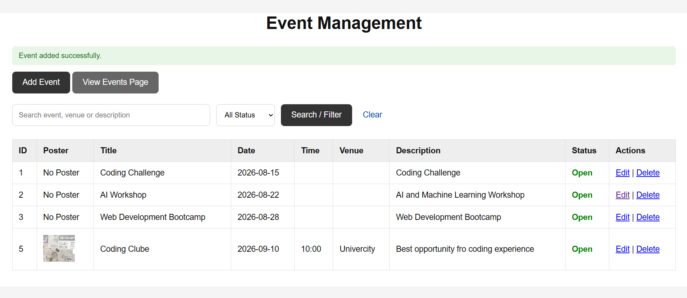
D. GitHub Repository Link
https://github.com/Avi4522/StudentHub/tree/main/Practical-12
E. Challenges Faced
I initially faced an 'Unknown column title in events' error because the existing events table had event_id, event_name, event_date, and description instead of the required Practical-12 column names. I fixed the database structure by changing the existing column names and adding the missing columns without dropping the table.
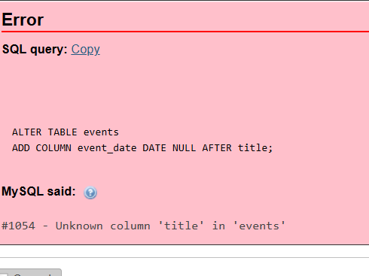

F. Learning Outcomes
I learned how to implement CRUD operations for event records using PHP and MySQLi. I also learned event search and filtering, status management, poster upload validation, file handling, database updates, and deletion of associated files.
Faculty Remarks:

